Intro Of Study App Application :

The ultimate goal of this study application is to make learning more effective, efficient, and enjoyable. By providing a range of features that cater to different learning styles and preferences, study app aim to empower users to take control of their learning journey and achieve their educational objectives.

Microsoft Project plan for developing a study app application :

Project Initiation :

* Purpose & scope of the study app.
* Identify key stakeholders, project team members & their roles.
* Project goals and objectives.

Requirements Gathering :

* App features & functionality : such as study materials, quizzes, progress tracking, & user profiles.
* User Experience Design : plan & design user interface (UI) & user experience (UX) for the app.

Design & Planning :

* App architecture & technology stack.
* Wireframes & mockups.

Development :

* Front-end Development : develop app’s front-end components, including UI elements & user interactions.
* Back-end Development : build back-end server, database & APIs required for the app’s functionality.
* Integration & Testing : integrate front-end & back-end components and conduct through testing.

Quality Assurance :

* Testing & bug fixing : identify & resolve issues or bugs in the app through rigorous testing.
* Performance optimization : optimize the app’s performance, responsiveness & time load.

Deployment :

* App launch plan : app store submissions.
* Marketing materials & user communication.

Post-launch Activities ;

* User support & feedback : provide user support & address feedback & issues post-launch.
* Ongoing updates & enhancements : plan for future updates & enhancements to the app’s features based on user feedback.

Project Closure :

* Conduct a project review to evaluate the success of the study app application development.
* Finalize documentation, including user guides & technical specifications.

**Task : 01 :**

Make MS Project file for study app.

.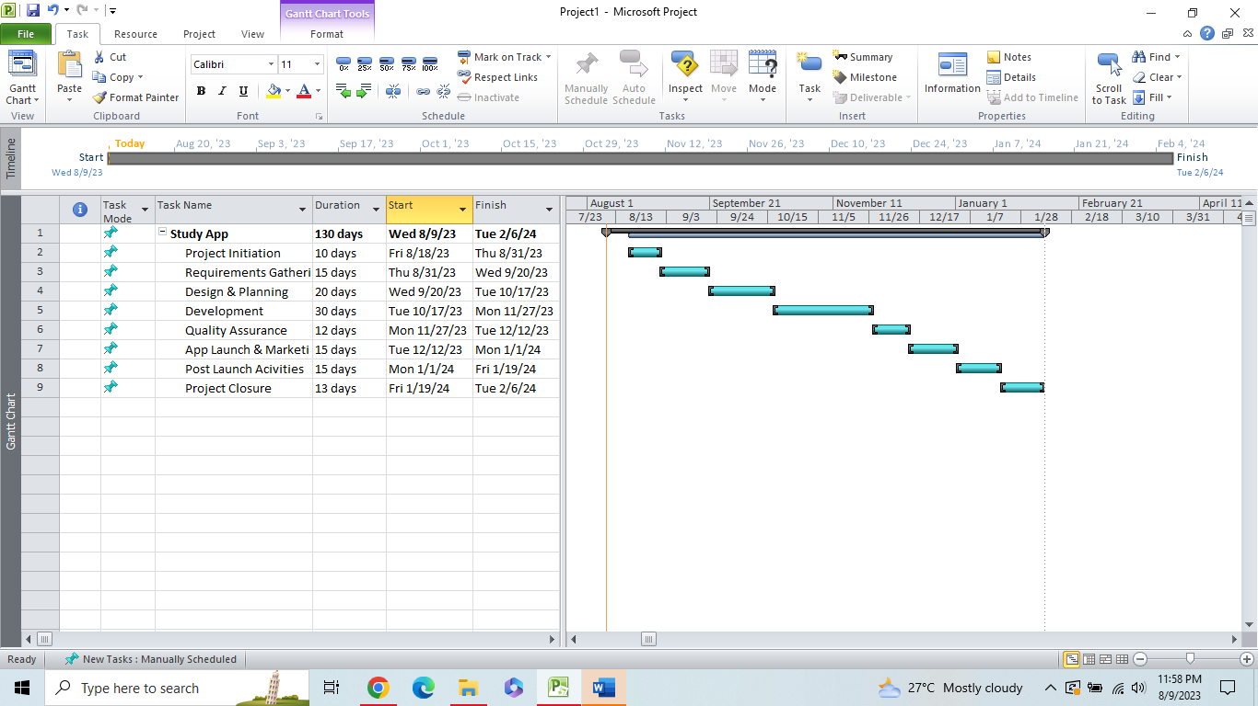

**Task : 02 :**

Add sub tasks & milestones & create calendar. 